**EXPERIMENT 11**

**PROCEDURES**

**Aim:**

* Create a table with attributes students and marks.
* Insert values into the table.
* Create a procedure to get the merit students (marks > 50).
* Create a procedure to get marks of a given id (using in).
* Create a procedure to display highest marks (using out).
* Create a procedure to get marks of a given id (using in and out).

**Components:**

* A procedures or a function is a group or set of SQL and PL/SQL statements that performs a specific task.

**Schema:**

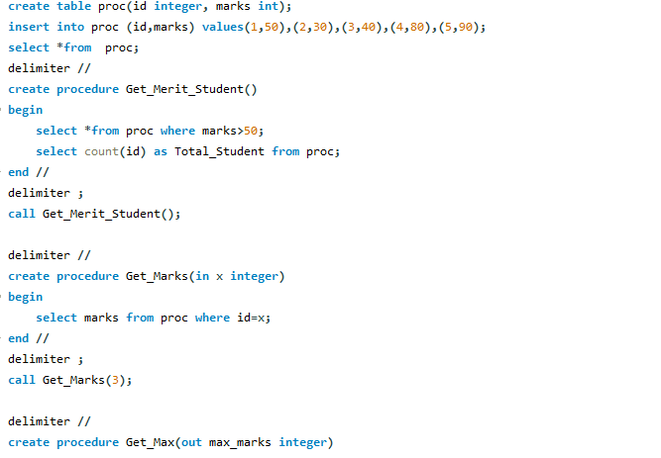

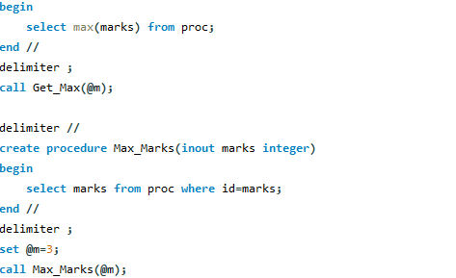

**Output:**

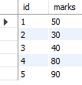

C:\Users\hi\Pictures\Screenshots\proc2.png

C:\Users\hi\Pictures\Screenshots\proc3.png

C:\Users\hi\Pictures\Screenshots\proc4.png

C:\Users\hi\Pictures\Screenshots\proc5.png

C:\Users\hi\Pictures\Screenshots\proc5.png

C:\Users\hi\Pictures\Screenshots\proc6.png